Operator Guideline for Efficient Image Denoiser

Table of Contents

1 Precautions 3
2 Common Definitions 4
3 Operator Tips 5

Precautions
- TFLite is only input format to run on our mobile device, and detailed information can be found in Tensorflow TFLite site: https://www.tensorflow.org/lite.
- GPU acceleration is possible when participants follow this guideline for operator limitation. In other case, performance drop might be happened.
- Higher score could be guaranteed when model is generated in accordance with this guideline.
- The execution of a model on device may fail for a variety of uncontrollable reasons. In such a case, “runtime error” will be reported instead of the score.

Common Definitions
- n_input: the number of input tensors for one operator
- n_output: the number of output tensors for one operator
- N_in: the batch size of input tensor
- C_in: the channel of input tensor
- H_in: the height of input tensor
- W_in: the width of input tensor
- N_out: the batch size of input tensor
- C_out: the channel of output tensor
- H_out: the height of output tensor
- W_out: the width of output tensor
- input_dim: (N_in, H_in, W_in, C_in)
- output_dim: (N_out, H_out, W_out, C_out)
- K_h: the kernel height of convolution
- K_w: the kernel width of convolution

Operator Tips
- All the operators listed below will be accelerated by GPU, but recommended configurations might get better acceleration effect than other configurations.
- The Tensorflow TFLite operators which don't appear in the below list will run on CPU fallback.

ID | Operator | Recommended Configuration | Remark
1 | ADD | - n_input == 2 && input_dim == output_dim  - For input_dim != output_dim && n_input == 2, one input tensor should have: H_in == 1 && W_in == 1
2 | AVERAGE_POOL_2D | -
3 | BIDIRECTIONAL_SEQUENCE_LSTM | -
4 | CONCATENATION | - (axis == 0 || axis == 1 || axis == 2) && n_input == 2  - axis == 3 && n_input <= 6 | axis: the concate axis for CONCATENATION in NHWC order
5 | CONV_2D | - group_size == 1 && dilation_width_factor == 1 && dilation_height_factor == 1 && K_h == K_w && K_h == 1, 3, 5, 7, 9 | - Satisfying "W_out%8==0, C_out % 8 == 0, C_in % 8 == 0" would be better  - group_size: the group number of one convolution  - Dilation related definitions are as below in TFLite:  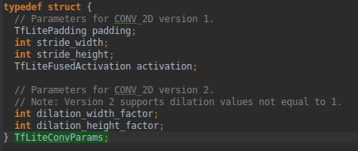
6 | DEPTHWISE_CONV_2D | - depth_multiplier == 1 && ( (dilation_height_factor == 4 && dilation_width_factor == 4) || (dilation_height_factor == 2 && dilation_width_factor == 2) ) && K_h == 3 && K_w == 3 && stride_width == 1 && stride_height == 1  - dilation_height_factor == 1 && dilation_width_factor == 1 && K_h == 3 && K_w == 3 && ( (stride_width == 1 && stride_height == 1) || (stride_width == 2 && stride_height == 2) ) | - Related definitions are as below in TFLite:  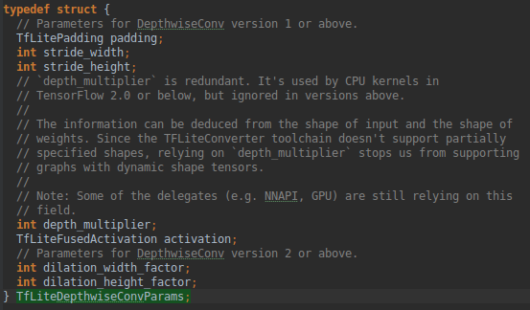
7 | DEPTH_TO_SPACE | -
8 | DIV | - n_input == 2 && input_dim == output_dim
9 | FULLY_CONNECTED | - (C_in * H_in * W_in) % 256 == 0 would be better
10 | GATHER | -
11 | LOGISTIC | -
12 | MAX_POOL_2D | -
13 | MEAN | - axis == 0 && H_in == 1 && W_in == 1 && C_in == 1  - axis == 3 && H_in == 1 && W_in == 1  - axis == 1 && W_in == 1  - axis == 2 | axis: the parameter for MEAN in NHWC order
14 | MUL | - n_input == 2 && input_dim == output_dim
15 | REDUCE_MIN | -
16 | RELU | 1. Directly follow ADD , CONV_2D, DEPTHWISE_CONV_2D, TRANSPOSE_CONV
17 | RESHAPE | -
18 | RESIZE_BILINEAR | - | RESIZE_BILINEAR may have accuracy problem on GPU, so it may use CPU fallback
19 | SOFTMAX | - axis == 3 && C_in % 8 == 0 | axis: the parameter for SOFTMAX in NHWC order
20 | SPLIT | - N_in = 1 && axis == 3 && n_output == 2 | axis: the parameter for SPLIT in NHWC order
21 | SQUEEZE | -
22 | SUB | - n_input == 2 && input_dim == output_dim
23 | TANH | -
24 | TRANSPOSE_CONV | - group_size == 1 && TfLitePadding == kTfLitePaddingValid && stride_height == K_h && stride_width == K_w && stride_height == 2 && stride_width == 2  - group_size == 1 && K_h * K_w % 4 == 0 | - group_size: the group number of transpose convolution  - Related definitions are as below in TFLite:  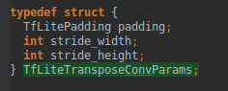  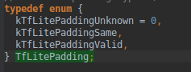

- For full list of supported operators by Tensorflow TFLite, please refer to: https://www.tensorflow.org/mlir/tfl_ops

